

“For we do not proclaim ourselves; We proclaim Jesus Christ as Lord”
1 Corinthians 2 v 4

WELCOME TO ST. CYPRIAN’S EPISCOPAL CHURCH

The Link – Sunday 6th May, 2007 – Easter 5

We welcome all visitors to our service this morning and

invite you to join us in the hall for coffee after the 10.30am service.

9.15 am – Holy Communion



10.30 am – Sung Eucharist

Prelude

Introit: 199 Immortal, Invisible, God only wise ...

First Reading: Acts 11.1-18
Responsorial: Psalm 148
Epistle: Revelation 21.1-6

Gradual: 372 Have faith in God, my heart ...

Gospel: John 13.31-35

Offertory: 367 God of grace and God of glory ...

Communion 1: 259 My God and is thy table spread ...
Communion 2: 279 My God accept my heart this day ...

Recessional: 509 Rise and hear! The Lord is speaking ...

Postlude
Please note:- There will be service at Lillyburn at 3.00pm today.

COLLECT
Almighty God, who through your only begotten Son Jesus Christ have overcome death and opened to us the gate of everlasting life: grant that, as by your grace going before us you put into our minds good desires, so by your continual help we may bring them to good effect; through Jesus Christ our risen Lord, who is alive and reigns with you, in the unity of the Holy Spirit, one God, now and forever.

FIRST READING: Acts 11.1-18
Now the apostles and the believers who were in Judea heard that the Gentiles had also accepted the word of God. So when Peter went up to Jerusalem, the circumcised believers criticized him, saying, ‘Why did you go to uncircumcised men and eat with them?’ Then Peter began to explain it to them, step by step, saying, ‘I was in the city of Joppa praying, and in a trance I saw a vision. There was something like a large sheet coming down from heaven, being lowered by its four corners; and it came close to me. As I looked at it closely I saw four-footed animals, beasts of prey, reptiles, and birds of the air. I also heard a voice saying to me, “Get up, Peter; kill and eat.” But I replied, “By no means, Lord; for nothing profane or unclean has ever entered my mouth.” But a second time the voice answered from heaven, “What God has made clean, you must not call profane.” This happened three times; then everything was pulled up again to heaven. At that very moment three men, sent to me from Caesarea, arrived at the house where we were. The Spirit told me to go with them and not to make a distinction between them and us. These six brothers also accompanied me, and we entered the man’s house. He told us how he had seen the angel standing in his house and saying, “Send to Joppa and bring Simon, who is called Peter; he will give you a message by which you and your entire household will be saved.” And as I began to speak, the Holy Spirit fell upon them just as it had upon us at the beginning. And I remembered the word of the Lord, how he had said, “John baptized with water, but you will be baptized with the Holy Spirit.” If then God gave them the same gift that he gave us when we believed in the Lord Jesus Christ, who was I that I could hinder God?’ When they heard this, they were silenced. And they praised God, saying, ‘Then God has given even to the Gentiles the repentance that leads to life.’

RESPONSORIAL PSALM: Psalm 148
The response is:- Praise, O praise the name of the Lord.
Praise the Lord! Praise the Lord from the heavens; praise him in the heights! Praise him, all his angels; praise him, all his host! Praise him, sun and moon; praise him, all you shining stars! - R
Praise him, you highest heavens, and you waters above the heavens! Let them praise the name of the Lord, for he commanded and they were created. He established them for ever and ever; he fixed their bounds, which cannot be passed. - R
Praise the Lord from the earth, you sea monsters and all deeps, fire and hail, snow and frost, stormy wind fulfilling his command! Mountains and all hills, fruit trees and all cedars! Wild animals and all cattle, creeping things and flying birds! - R
Kings of the earth and all peoples, princes and all rulers of the earth! Young men and women alike, old and young together! Let them praise the name of the Lord, for his name alone is exalted; his glory is above earth and heaven. - R
He has raised up a horn for his people, praise for all his faithful, for the people of Israel who are close to him. Praise the Lord! - R

EPISTLE: Revelation 21.1-6
Then I saw a new heaven and a new earth; for the first heaven and the first earth had passed away, and the sea was no more. And I saw the holy city, the New Jerusalem, coming down out of heaven from God, prepared as a bride adorned for her husband. And I heard a loud voice from the throne saying, ‘See, the home of God is among mortals. He will dwell with them; they will be his peoples, and God himself will be with them; he will wipe every tear from their eyes. Death will be no more; mourning and crying and pain will be no more, for the first things have passed away.’
And the one who was seated on the throne said, ‘See, I am making all things new.’ Also he said, ‘Write this, for these words are trustworthy and true.’ Then he said to me, ‘It is done! I am the Alpha and the Omega, the beginning and the end. To the thirsty I will give water as a gift from the spring of the water of life.

GOSPEL: John 13.31-35
When he had gone out, Jesus said, ‘Now the Son of Man has been glorified, and God has been glorified in him. If God has been glorified in him, God will also glorify him in himself and will glorify him at once. Little children, I am with you only a little longer. You will look for me; and as I said to the Jews so now I say to you, “Where I am going, you cannot come.” I give you a new commandment, that you love one another. Just as I have loved you, you also should love one another. By this everyone will know that you are my disciples, if you have love for one another.’

POST COMMUNION PRAYER
Eternal God, whose Son Jesus Christ is the way, the truth, and the life: grant us to walk in his way, to rejoice in his truth, and to share his risen life; who is alive and reigns now and forever.
SERVICES

Sun 6th EASTER 5 Sun 13th EASTER 6
9.15am Holy Communion Start of Christian Aid Week
10.30am Sung Eucharist 9.15am Holy Communion
3.00pm Service at Lillyburn 10.30am Sung Eucharist
6.30pm Romania Today
Thu 10th
10am Holy Communion

THIS WEEK IN PRAYER
Pray for the peace of Jerusalem: “May they prosper who love you,” Psalm 122:6

For your prayers this week:
In the Anglican Cycle of prayer we are asked to pray for the people of The Diocese of North Kerala in the Province of South India and for their Bishop, The Rt Revd Dr George Isaac
In our own Diocese we should pray for the congregation of the church of St John the Evangelist, in Dumfries and the Rev Canon Robin Paisley; also for Christ Church in Dalbeattie, and the Rev Canon Ken Stephen, Rev Beryl Scott and Rev Richard Stephens.

Please also remember in your prayers:
Pam Bentley & the family, Gavin Boyd, Bill Ferry, Audrey Groom & the family, Nancy Hogg, Peter Mundy, Hannah Rose, James Sanderson and all those on the prayer board. May God keep them in His care.



He laid his right hand upon
me, saying, “Fear not, I am
the first and the last,
and the living one.”
Revelation 1.17-18a
Aid/Sam Faulkner

Cyprian

LIFE
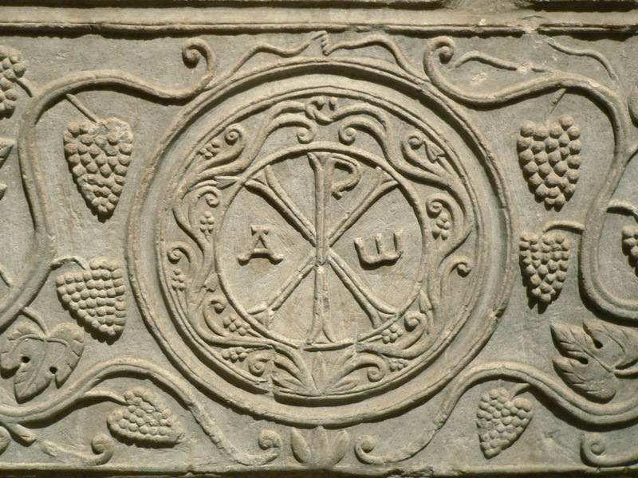

The Magazine of St Cyprian’s Church Lenzie
May/June 2007
New Issue
OUT TODAY
Pick one up in Church

See “Cyprian Life” for details of CHRISTIAN AID NEWS


TREE PLANTING Sunday May 6th 2007
1.30pm in Woodhead Park

CHRISTIAN AID WEEK from 13th to 19th May 2007

3 helpers still to be found

CHRISTIAN AID COFFEE MORNING
Wednesday 16th May at 10.00am – 12 noon
in St Cyprian’s Church Hall
Helpers and home baking needed
Tel:- Eileen Ferry on 775 0621

THE LINK
Please forward any notices for the link to Kathryn Potts
on 578 0734,
or e-mail to kathryn.potts2@ntlworld.com before 6pm on Wednesdays. Thank you.

OPEN GARDENS WEEKEND

Anyone interested in taking part in
the “Open Gardens” scheme this year
for the Lenzie Churches Open Garden
Weekend in July 2007 please give your
name to Viviennne Provan.
Tel:- 0141-776 6422


Bring & Share Tea

at Susan Frost’s, 35 Earlsburn Rd,
on 7th May 2007 at 6.30pm.
All welcome particularly if you can help with the Strawberry Fayre on 23rd June.

Offers of food will be much appreciated –
Tel:- Aileen on 578 9449 for information on food suggestions.



‘SINGING PRAISE’
Sunday 20th May 2007 at 6.30pm

An informal service of praise followed by a light supper in the church hall.
Please see poster for details
You choose the hymns, then come along and sing your favourites !
Please use the tear off slip below to intimate your choice of Hymns and place in the box at the back of the church. We will do our best to incorporate as many as possible into the service.

- - - - - - - - - - - - - - - - - - - - - - - - - - - - - - - - - - - - - - - - - - - - - - - -
Hymn no. Book (A&M or Source) First Lines
1.
- - - - - - - - - - - - - - - - - - - - - - - - - - - - - - - - -
2.
- - - - - - - - - - - - - - - - - - - - - - - - - - - - - - - - -
3.
- - - - - - - - - - - - - - - - - - - - - - - - - - - - - - - - -
4.

