

“For we do not proclaim ourselves; we proclaim Jesus Christ as Lord”
1 Corinthians 2 v 4

WELCOME TO ST. CYPRIAN’S EPISCOPAL CHURCH

THE LINK – Sunday 20th April, 2008
4th Sunday after Easter (Easter 5)

We welcome all visitors to our service and

invite you to join us for coffee in the hall after the 10.30am service.

9.15am – Holy Communion

10.30am – Sung Eucharist

Introit: 199 Immortal, invisible, God only wise...
First Reading: Acts 7:55-60 (Vivienne Provan)
Responsorial: Psalm 31:1-5,15-16
Epistle: I Peter 2:2-10 (Kathryn Potts)
Gradual: 244 Hark, my soul, it is the Lord...
Gospel: John 14:1-14
Offertory : 367 God of grace and God of glory...
Communion 1: 134 Loving shepherd of thy sheep...
Communion 2: 279 My God, accept my heart...omit v 5
Recessional: 141 The head that once was crowned...

COLLECT:
Almighty God, who through your only begotten Son Jesus Christ, have overcome death and opened to us the gate of everlasting life: grant that, as by your grace going before us, you put into our minds good desires, so by your continual help we may bring them to good effect; through Jesus Christ our risen Lord, who is alive and reigns with you, in the unity of the Holy Spirit, one God, now and forever.
FIRST READING: Acts 7:55-60 (Vivienne)
But filled with the Holy Spirit, he gazed into heaven and saw the glory of God and Jesus standing at the right hand of God. ‘Look,’ he said, ‘I see the heavens opened and the Son of Man standing at the right hand of God!’ But they covered their ears, and with a loud shout all rushed together against him. Then they dragged him out of the city and began to stone him; and the witnesses laid their coats at the feet of a young man named Saul. While they were stoning Stephen, he prayed, ‘Lord Jesus, receive my spirit.’ Then he knelt down and cried out in a loud voice, ‘Lord, do not hold this sin against them.’ When he had said this, he died.
RESPONSORIAL PSALM: Psalm 31
Response is:- Let your face shine on your servants
In you, O Lord, I seek refuge; do not let me ever be put to shame; in your righteousness deliver me. Incline your ear to me; rescue me speedily. – R
Be a rock of refuge for me, a strong fortress to save me. You are indeed my rock and my fortress; for your name’s sake lead me and guide me, – R
take me out of the net that is hidden for me, for you are my refuge. Into your hand I commit my spirit; you have redeemed me, O Lord, faithful God. – R
My times are in your hand; deliver me from the hand of my enemies and persecutors. Let your face shine upon your servant; save me in your steadfast love. – R
Epistle: I Peter 2:2-10 (Kathryn)
Like newborn infants, long for the pure, spiritual milk, so that by it you may grow into salvation— if indeed you have tasted that the Lord is good.
Come to him, a living stone, though rejected by mortals yet chosen and precious in God’s sight, and like living stones, let yourselves be built into a spiritual house, to be a holy priesthood, to offer spiritual sacrifices acceptable to God through Jesus Christ. For it stands in scripture:
‘See, I am laying in Zion a stone, a cornerstone chosen and precious;
and whoever believes in him will not be put to shame.’ To you then who believe, he is precious; but for those who do not believe, ‘The stone that the builders rejected has become the very head of the corner’,
and ‘A stone that makes them stumble, and a rock that makes them fall.’ They stumble because they disobey the word, as they were destined to do. But you are a chosen race, a royal priesthood, a holy nation, God’s own people, in order that you may proclaim the mighty acts of him who called you out of darkness into his marvelous light. Once you were not a people, but now you are God’s people; once you had not received mercy, but now you have received mercy.

GOSPEL: John 14:1-14
‘Do not let your hearts be troubled. Believe in God, believe also in me. In my Father’s house there are many dwelling-places. If it were not so, would I have told you that I go to prepare a place for you? And if I go and prepare a place for you, I will come again and will take you to myself, so that where I am, there you may be also. And you know the way to the place where I am going.’ Thomas said to him, ‘Lord, we do not know where you are going. How can we know the way?’ Jesus said to him, ‘I am the way, and the truth, and the life. No one comes to the Father except through me. If you know me, you will know my Father also. From now on you do know him and have seen him.’
Philip said to him, ‘Lord, show us the Father, and we will be satisfied.’ Jesus said to him, ‘Have I been with you all this time, Philip, and you still do not know me? Whoever has seen me has seen the Father. How can you say, “Show us the Father”? Do you not believe that I am in the Father and the Father is in me? The words that I say to you I do not speak on my own; but the Father who dwells in me does his works. Believe me that I am in the Father and the Father is in me; but if you do not, then believe me because of the works themselves. Very truly, I tell you, the one who believes in me will also do the works that I do and, in fact, will do greater works than these, because I am going to the Father. I will do whatever you ask in my name, so that the Father may be glorified in the Son. If in my name you ask me for anything, I will do it.
Prayer for Humble Access:
We do not presume to come to this your table, trusting in our own righteousness, but in your manifold and great mercies. We are not worthy so much as to gather up the crumbs under your table. But you are the same Lord whose nature is always to have mercy. Grant us therefore, Gracious Lord, so to eat the Flesh of your dear Son, Jesus Christ, and to drink His Blood, that we may evermore dwell in him and he in us.

POST COMMUNION PRAYER:
Eternal God, whose Son Jesus Christ is the way, the truth and the life: grant us to walk in his way, to rejoice in his truth, and to share his risen life; who is alive and reigns, now and forever.
THIS WEEK IN PRAYER
Pray for the peace of Jerusalem: “May they prosper who love you,” Psalm 122:6
For your prayers this week:
In the Anglican Cycle of Prayer we are asked to pray for The Church of Ireland The Most Revd Alan Edwin Thomas Harper Primate of All Ireland & Archbishop of Armagh. In our own Diocese we should pray for the South Ayrshire Team: Holy Trinity, Ayr; St John’s, Girvan; St Oswald’s, Maybole (Ian Meredith)

Daily Prayers:-
21st Prisoners of conscience 22nd The Bishop’s Staff Group
23rd The people of England (St George) 24th The St Cyprian’s 3C group
25th Missionaries and evangelists (Mark) 26th Thanks for the Gospels

Please also remember in your prayers:
Glynn Jones; Jonathon Kerr; Mary Kitching; Bill Morris; Ian Parry; Jenny Proctor; Hannah Rose; James Sanderson; Ruth Wallace; Anne Carswell’s sister Veronica, and all those on the prayer board. May God keep them all in His care.

SERVICES and events
APRIL Sun 20th Fourth Sunday after Easter (Easter 5)
9.15am Holy Communion (said)
10.30am Sung Eucharist
6.30pm Christian Aid Service at St Mary’s
Thur 24th 10am Holy Communion in the Choir Vestry
Fri 25th Mark, Evangelist
Sat 26th 10am - 12 Bible Society Coffee Morning, Lenzie Old.
Sun 27th Fifth Sunday after Easter (Easter 6)
9.15am Holy Communion (said)
10.30am Sung Eucharist / Sermon Discussion
MAY Thur 1st Ascension Day
10am Holy Communion in the Choir Vestry
Fri 2nd Philip and James, Apostles
Sat 3rd New Life; the Spirit
Sun 4th Sunday after Ascension
9.15am Holy Communion (said)
10.30am Sung Eucharist
3pm Holy Communion at Lillyburn
BIBLE SOCIETY
Coffee Morning
26th April 2008
Lenzie Old Parish
Church Hall
10am to noon





In preparation for Christian Aid week,
Kirkintilloch and Lenzie Christian Aid Group
is holding a joint service of worship,
song and information.
It is hoped that all 8 churches
in the group will be represented.
11th - 17th May 2008
CHRISTIAN AID
Sunday 20th April at 6.30pm
In St Mary’s Church, Kirkintilloch
Music – Kelvin Brass and the Keynotes
Speaker – Gavin McLellan
(Scottish Secretary for Christian Aid)
Tea in St Mary’s Church Hall

Please forward notices for the link to Kathryn Potts on 578 0734,
or e-mail to link@stcyprianslenzie.com or kathryn.potts2@ntlworld.com by Wednesday at 6.00pm. Thank you.


Congratulations
The Clergy, Vestry and congregation of St Cyprian’s wish every happiness to Kevin and Fiona Wilbraham as they celebrate their First Wedding Anniversary on Monday 21th April

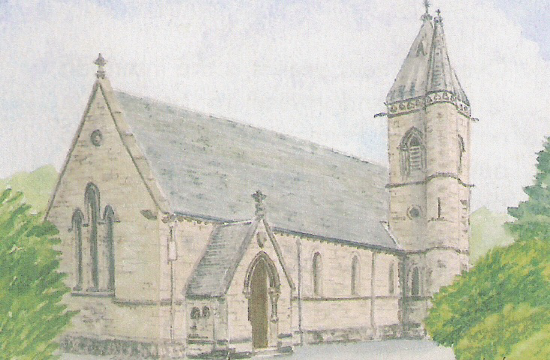
Worship Forum:
Facing the Future
Sunday 27th April
After the 10.30am service

This is an opportunity for the Staff Group (i.e. Geoff, Moira, Eric & Glennis) to listen to your views on the worship and consider ideas for the future. All members of the congregation are encouraged to come along to this discussion group – it is your church – you have a say in what happens next ! A light lunch of rolls and soup will be provided.

St Cyprian’s 3Cs Group
The previously cancelled Spring Fair has now been re-scheduled to
Saturday 10th May 2008
Coffee Morning
10am – 12noon
In St Cyprian’s Church Hall
Tearoom and cake and candy stall
Tickets available today from Catherine Gunnee or at the back of the church.

