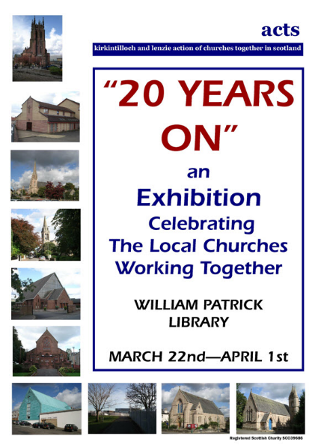
Kirkintilloch and Lenzie Acts Group
Action of Churches Together in Scotland
Ecumenical Exhibition

This events takes place in the William Patrick Library from Monday 22nd March until Thursday 1st April, during normal Library opening hours.


REFLECTIONS FOR HOLY WEEK
with CONCORDIA ALL WELCOME

PALM SUNDAY
ST.DAVID’S CHURCH,
ALEXANDRA St., KIRKINTILLOCH
March 28th at 7.00PM
Also at the Carmelite Monastery, Waterside Road,
on Mon 29th March, at 7.30pm


STOCK CUBES NEEDED
Special appeal from Andrew Low of the City Mission for more Knorr Stock Cubes (Chicken, Veg or Ham - no beef) for Glasgow City Mission as they are running out. Please leave at the back of the church or in the choir vestry. Thankyou.



Sally and Andrew
have great pleasure in inviting you to join them
at the service to celebrate their marriage,
in St Cyprian’s Church, Lenzie
on Friday 16th April 2010, at 2pm
and afterwards in the Church Hall,
for light refreshments.



The Christian Aid Coffee Morning is to be held on WED 12th MAY in the Church Hall ( if building work allows) It has been decided not to go ahead with the MU Games Night that evening as quite a number of the MU Branch are involved in the Coffee Morning; instead we will have a
Summer Evening out on WED 19th MAY
at The Boathouse, Auchinstarry Basin.
EVERYONE WELCOME.
Please give your name along with a deposit of £10,
to Eileen Ferry by 2nd MAY.

REMINDER:- there is no MU meeting in April due to Easter.

All MU annual subscriptions are due NOW and should be given to ERIC as soon as possible. (£12.50)
Thanks, Catherine

