

“For we do not proclaim ourselves; we proclaim Jesus Christ as Lord”
1 Corinthians 2 v 4

WELCOME TO ST CYPRIAN’S EPISCOPAL CHURCH
THE LINK – Sunday 14th November, 2009
The Second Sunday before Advent
Remembrance Sunday

We welcome all visitors to our service and
invite you to join us for coffee in the hall after the 10.30am service.

9.15am – Holy Communion



10.30am – Sung Eucharist WITH LAYING OF the WREATH

This morning, we welcome our Celebrant,
the the Rt Revd Gregor Duncan, Bishop of Glasgow and Galloway.

C. Grace and peace to you from God our Father and the
Lord Jesus Christ.
P. AMEN

Introit hymn: 99 O God our help in ages past.... omit V 5

Sharing of the peace

C. We meet in Christ’s name.
P. Let us share His peace.

C. We are here to worship Almighty God whose purposes are good; whose power sustains the world He has made; who
loves us, who gave Jesus Christ for the life of the world;
who by His Holy Spirit leads us in His way.

P. As we give thanks for His great works, we remember those
who have lived and died in His service and in the service of
others; we pray for all who suffer through war and are in need; we ask for His help and blessing that we may do His
will, and that the whole world may acknowledge Him as Lord and King. AMEN.

GLORIA - to the tune Cwm Rhondda (Text: Edwin le Grice © Kevin Mayhew)

Glory be to God in heaven, songs of joy and peace we bring,
thankful hearts and voices raising, to creation's Lord we sing.
Lord, we thank you, Lord, we bless you,
glory be to God our King, glory be to God our King

Lamb of God, who on your shoulders bore the load of this world's sin,
only Son of God the Father, you have brought us peace within.
Lord, have mercy, Christ have mercy,
now your glorious reign begin, now your glorious reign begin.

COLLECT:
Almighty Father, whose will is to restore all things in your beloved Son, the King of all: govern the hearts and minds of those in authority, and bring the families of the nations, divided and torn apart by the ravages of sin, to be subject to his just and gentle rule; who is alive and reigns with you, in the unity of the Holy Spirit, one God, now and for ever.

FIRST READING: Malachi 4.1-2 (Sandy Jamieson)
See, the day is coming, burning like an oven, when all the arrogant and all evildoers will be stubble; the day that comes shall burn them up, says the Lord of hosts, so that it will leave them neither root nor branch. But for you who revere my name the sun of righteousness shall rise, with healing in its wings. You shall go out leaping like calves from the stall.

EPISTLE: 2 Thessalonians 3.6-13 (Kevin Wilbraham)
Now we command you, beloved, in the name of our Lord Jesus Christ, to keep away from believers who are living in idleness and not according to the tradition that they received from us. For you yourselves know how you ought to imitate us; we were not idle when we were with you, and we did not eat anyone’s bread without paying for it; but with toil and labour we worked night and day, so that we might not burden any of you. This was not because we do not have that right, but in order to give you an example to imitate. For even when we were with you, we gave you this command: Anyone unwilling to work should not eat. For we hear that some of you are living in idleness, mere busybodies, not doing any work. Now such persons we command and exhort in the Lord Jesus Christ to do their work quietly and to earn their own living. Brothers and sisters, do not be weary in doing what is right.
GRADUAL HYMN: 82 Jesus lives!.....

GOSPEL: Luke 21.5-19
When some were speaking about the temple, how it was adorned with beautiful stones and gifts dedicated to God, he said, ‘As for these things that you see, the days will come when not one stone will be left upon another; all will be thrown down.’ They asked him, ‘Teacher, when will this be, and what will be the sign that this is about to take place?’ And he said, ‘Beware that you are not led astray; for many will come in my name and say, “I am he!” and, “The time is near!” Do not go after them. ‘When you hear of wars and insurrections, do not be terrified; for these things must take place first, but the end will not follow immediately.’ Then he said to them, ‘Nation will rise against nation, and kingdom against kingdom; there will be great earthquakes, and in various places famines and plagues; and there will be dreadful portents and great signs from heaven. ‘But before all this occurs, they will arrest you and persecute you; they will hand you over to synagogues and prisons, and you will be brought before kings and governors because of my name. This will give you an opportunity to testify. So make up your minds not to prepare your defence in advance; for I will give you words and a wisdom that none of your opponents will be able to withstand or contradict. You will be betrayed even by parents and brothers, by relatives and friends; and they will put some of you to death. You will be hated by all because of my name. But not a hair of your head will perish. By your endurance you will gain your souls.
SERMON

Please all stand for the
The Laying of the Wreath

C. They shall grow not old,
As we that are left grow old:
Age shall not weary them,
Nor the years condemn,
At the going down of the sun
And in the morning
(Laurence Binyon (1869-1943))

P. “We Will Remember Them”

Two Minutes Silence will now be observed.

The Last Post

We now sing the verses 1 and 3 of the National Anthem
(No. 293 in the Red Hymn Book)

ACT OF COMMITMENT:

- Let us pledge ourselves anew to the service of God and our neighbours that we may help, encourage and comfort others and support those working for the relief of the needy and for the peace and welfare of nations.

- Lord God, we pledge ourselves to serve you and all humankind for the relief of want and suffering and for the praise of your name. Guide us by your Holy Spirit, give us wisdom, give us courage, give us hope and keep us faithful, now and always. Amen.

NICENE CREED

INTERCESSIONS

CONFESSION AND ABSOLUTION:

C. Let us confess to God the sins and shortcomings of the world; its pride, its selfishness, its greed; its evil divisions and hatreds. Let us confess our share in what is wrong, and our failure to seek and establish that peace which God wills for His children.
P. Most merciful God, we confess that we have sinned, in thought word and deed. We have not loved you with our whole heart. We have not loved our neighbour as ourselves. In your mercy forgive what we have been, help us to amend what we are, and direct what we will be, so that we may do things justly, love mercy, and walk humbly with you.

- Almighty God have mercy upon us, pardon and deliver us from all our sins, confirm and strengthen us in all goodness, and keep us in life eternal; through Jesus Christ our Lord.

P. AMEN.

THE LITURGY OF THE SACRAMENT CONTINUES
ON PAGE 6 OF THE 1982 BLUE LITURGY BOOK.

OFFERTORY: 361 For the healing of the nations.....

COMMUNION HYMN: 362 Forgive our sins as we forgive.....

POST COMMUNION:
God of peace, whose Son Jesus Christ proclaimed the kingdom and restored the broken to wholeness of life: look with compassion on the anguish of the world, and by your healing power make whole both people and nations; through our Lord and Saviour Jesus Christ.

BLESSING DISMISSAL

NOTICES

RECESSIONAL HYMN: 292 Eternal father, strong to save.....

The ANNUAL GENERAL MEETING now follows in the hall.

THIS WEEK IN PRAYER
Pray for peace in Jerusalem: “May they prosper who love you,” Psalm 122:6
For your prayers this week:
In the Anglican Cycle of Prayer, we are asked to PRAY for Katsina - (Province of Kaduna, Nigeria) The Rt Revd Jonathan Sani Bamaiyi. In our own Diocese, please pray for St Mary the Virgin, Port Glasgow, Rev Andrew McMichael.
DAILY PRAYERS
15th Remembering Hiroshima: for freedom from nuclear weapons
16th For kindness of heart and a caring, generous nature.
17th For relief from famine for the African peoples
18th For the poor and the orphaned
19th For wisdom and integrity within the Civil Service
20th Staff and patients in hospitals, hospices and nursing homes
Please also remember in your prayers:
Graham Durkin (Eric and Prim’s son-in-law, who has recently been diagnosed with prostate cancer); Jean Dick; Susan Frost; Ray Hardman; Susan Iveson; Mary Kitching (Maxine’s Mum); Brian and Kate MacDonald (Sandy’s cousins); Bill Morris and his great grand-daughter, Mia; Prim Parry; Alan Paterson (Dorothy’s son); Vera Petzold; Bob Provan; Margaret Sneddon (Nancy Hogg's Sister in Law in Australia); Glennis Tavener; and all those on the prayer board.
May God keep them all in His care.

SERVICES AND EVENTS in September

Sun 14th Remembrance Sunday; Second before Advent
9.15am Holy Communion (said)
10.30am Sung Eucharist
c. 12.00noon AGM in the hall after the service
Tues 16th Margaret of Scotland, 1093
Thur 18th 10am Holy Communion in Choir Vestry

Sun 21st Christ the King
10.30am Sung Eucharist
3.00pm Afternoon Service (tea and Fair Trade)
Thur 25th 10am Holy Communion in Choir Vestry
Fri 26th 9-2&6-8 Preparation of Christmas Fayre
Sat 27th 10–2.30pm Christmas Fayre in Public Hall
Sun 28th Advent Sunday
9.15am Holy Communion (said)
10.30am Sung Eucharist
7pm ACTS Advent Service
with Concordia at St David’s
Memorial Park Church, Kirkintilloch
Tues 30th Andrew, Apostle, Patron of Scotland
7.30pm Advent Meditation in the Choir Vestry

St Cyprian’s Christmas Fayre

on Saturday 27th November
at 10.00am - 2.30pm
in LENZIE PUBLIC HALLS

TICKETS - adults £2; children £1
Refreshments included
Scottish Charity: SC003826

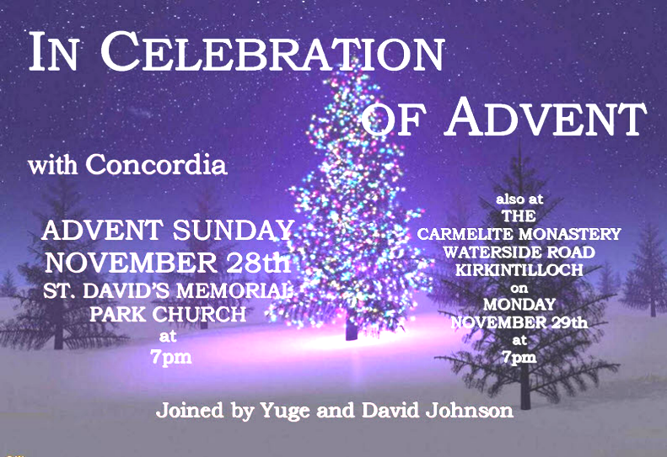
Tickets for the Christmas Fayre are available in Church now. Please take some and try to sell at least 5 each. Details as above – help will be needed in all departments. See “Cyprian Life” November issue, pages 12/13 for further information.
Mother’s Union
The next event will be the MU Christmas Party
Wednesday 8th December 2010 at 7.30pm.
All welcome and please bring along a friend.


Lenzie Action Group
Advent Afternoon

Thursday 2nd December from 2pm - 4pm
at Lenzie Union Parish Church New Hall
Come along and be entertained by the Reverend John Campbell and friends
while enjoying a pleasant afternoon tea.


Kirky Players Annual Pantomime
We intend to make a group booking for the
6.30pm performance on 22nd January 2011
(Oh no you’re not; Oh yes we are!)
The panto this year is “Cinderella.”
Please let Glennis Tavener know as soon as possible (by 14th November 2010 at the latest) how many tickets you would like, along with payment of £8 per ticket, so she can make the booking. Thanks.

Please forward notices to Kathryn on kathryn.potts2@ntlworld.com
or phone on 578 0734, by 6.00pm each Wednesday. Thank you.

