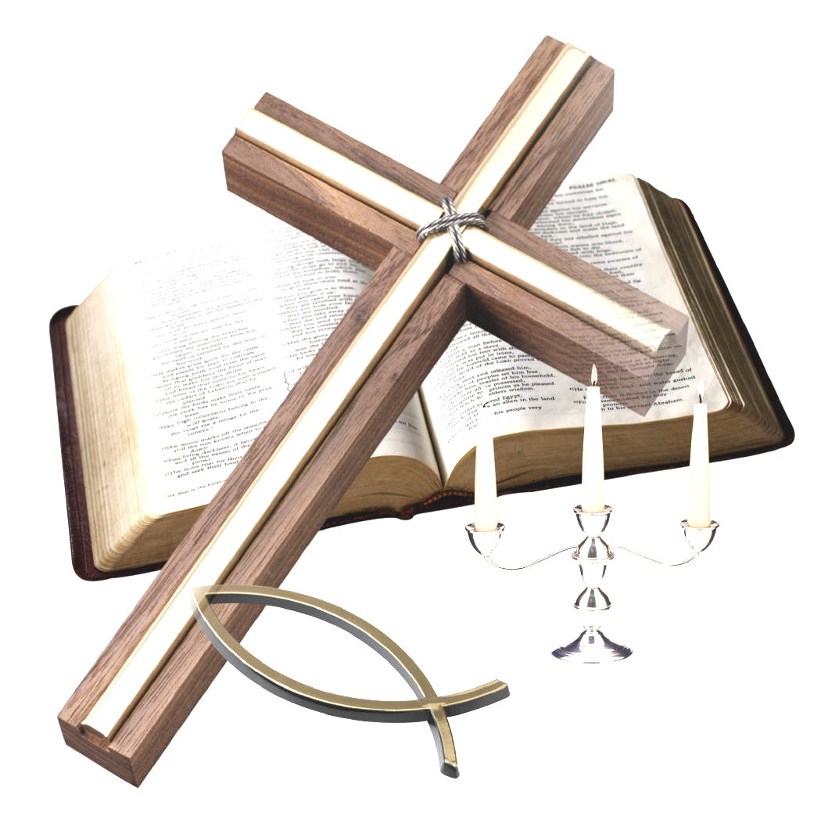

“For we do not proclaim ourselves; we proclaim Jesus Christ as Lord”
1 Corinthians 2 v 4

WELCOME TO ST CYPRIAN’S EPISCOPAL CHURCH
THE LINK – Sunday 12th June 2011
WHIT SUNDAY / PENTECOST

We welcome all visitors and invite you to join us for coffee
in the hall after the service.
9.15am – Holy communion (said)

10.30am – Sung Eucharist

hymns mostly from the source
Notices; Sharing of the peace
Service of The Eucharist using the 1982 ‘BLUE BOOK’

Introit hymn: 71 Come down, O Love divine...
COLLECT:
God, who as at this time taught the hearts of your faithful people by sending to them the light of your Holy Spirit: grant us by the same Spirit to have a right judgement in all things and evermore to rejoice in his holy comfort; through the merits of Christ Jesus our Saviour, who is alive and reigns with you, in the unity of the Holy Spirit, one God, now and for ever.

FIRST READING: Acts 2.1-21 Gavin Boyd
When the day of Pentecost had come, they were all together in one place. And suddenly from heaven there came a sound like the rush of a violent wind, and it filled the entire house where they were sitting. Divided tongues, as of fire, appeared among them, and a tongue rested on each of them. All of them were filled with the Holy Spirit and began to speak in other languages, as the Spirit gave them ability. Now there were devout Jews from every nation under heaven living in Jerusalem. And at this sound the crowd gathered and was bewildered, because each one heard them speaking in the native language of each. Amazed and astonished, they asked, ‘Are not all these who are speaking Galileans? And how is it that we hear, each of us, in our own native language? Parthians, Medes, Elamites, and residents of Mesopotamia, Judea and Cappadocia, Pontus and Asia, Phrygia and Pamphylia, Egypt and the parts of Libya belonging to Cyrene, and visitors from Rome, both Jews and proselytes, Cretans and Arabs - in our own languages we hear them speaking about God’s deeds of power.’ All were amazed and perplexed, saying to one another, ‘What does this mean?’ But others sneered and said, ‘They are filled with new wine.’
But Peter, standing with the eleven, raised his voice and addressed them: ‘Men of Judea and all who live in Jerusalem, let this be known to you, and listen to what I say. Indeed, these are not drunk, as you suppose, for it is only nine o’clock in the morning. No, this is what was spoken through the prophet Joel: “In the last days it will be, God declares, that I will pour out my Spirit upon all flesh, and your sons and your daughters shall prophesy, and your young men shall see visions, and your old men shall dream dreams. Even upon my slaves, both men and women, in those days I will pour out my Spirit; and they shall prophesy. And I will show portents in the heaven above and signs on the earth below, blood, and fire, and smoky mist. The sun shall be turned to darkness and the moon to blood, before the coming of the Lord’s great and glorious day. Then everyone who calls on the name of the Lord shall be saved.”

RESPONSORIAL PSALM: Psalm 104.26-37
Response:- Bless the Lord, O my soul. Praise the Lord!
There go the ships, and Leviathan that you formed to sport in it. These all look to you to give them their food in due season; when you give to them, they gather it up; when you open your hand, they are filled with good things. - R
When you hide your face, they are dismayed; when you take away their breath, they die and return to their dust. When you send forth your spirit, they are created; and you renew the face of the ground. - R
May the glory of the Lord endure for ever; may the Lord rejoice in his - works who looks on the earth and it trembles, who touches the mountains and they smoke. I will sing to the Lord as long as I live; I will sing praise to my God while I have being. May my meditation be pleasing to him, for I rejoice in the Lord. Let sinners be consumed from the earth, and let the wicked be no more. - R

EPISTLE: 1 Corinthians 12.3-13 Kathryn Potts
Therefore I want you to understand that no one speaking by the Spirit of God ever says ‘Let Jesus be cursed!’ and no one can say ‘Jesus is Lord’ except by the Holy Spirit. Now there are varieties of gifts, but the same Spirit; and there are varieties of services, but the same Lord; and there are varieties of activities, but it is the same God who activates all of them in everyone.
To each is given the manifestation of the Spirit for the common good. To one is given through the Spirit the utterance of wisdom, and to another the utterance of knowledge according to the same Spirit, to another faith by the same Spirit, to another gifts of healing by the one Spirit, to another the working of miracles, to another prophecy, to another the discernment of spirits, to another various kinds of tongues, to another the interpretation of tongues.
All these are activated by one and the same Spirit, who allots to each one individually just as the Spirit chooses. For just as the body is one and has many members, and all the members of the body, though many, are one body, so it is with Christ. For in the one Spirit we were all baptized into one body; Jews or Greeks, slaves or free; and we were all made to drink of one Spirit.
GRADUAL HYMN: Holy Spirit....Author unknown ; Welsh trad. Melody
2) Holy Spirit, Christ proclaimer,
wisdom bringer, light our way.
Fire that dances, wind that whispers,
Holy Spirit, come today.
Ease disturber, comfort bearer,
move among us while we pray.
Truth revealer, faith confirmer,
rest within our hearts today.
1) Holy Spirit, gift bestower,
breathe into our hearts today.
Flowing water, dove that hovers,
Holy Spirit, guide our way.
Love inspirer, joy releaser,
Spirit, take our fears away.
Reconciler, peace restorer,
move among us while we pray.
GOSPEL: John 20.19-23
When it was evening on that day, the first day of the week, and the doors of the house where the disciples had met were locked for fear of the Jews, Jesus came and stood among them and said, ‘Peace be with you.’ After he said this, he showed them his hands and his side. Then the disciples rejoiced when they saw the Lord. Jesus said to them again, ‘Peace be with you. As the Father has sent me, so I send you.’ When he had said this, he breathed on them and said to them, ‘Receive the Holy Spirit. If you forgive the sins of any, they are forgiven them; if you retain the sins of any, they are retained.’
OFFERTORY: 69 Colours of day...
COMMUNION: 462 Spirit of the living God....

POST COMMUNION prayer:
Faithful God, who fulfilled the promises of Easter by sending us your Holy Spirit and opening to every race and nation the way of life eternal: open our lips by your Spirit, that every tongue may tell of your glory; through Jesus Christ our Lord.

RECESSIONAL: 335 Lord the light of your love....
BLESSING DISmissal
THIS WEEK IN PRAYER
Pray for peace in Jerusalem: “May they prosper who love you,” Psalm 122:6
For your prayers this week:
In the Anglican Cycle of Prayer, we are asked to PRAY for Ohio (Province V, USA) and The Rt Revd Mark Hollingsworth. In our own Diocese, please pray for St Andrew, Wishaw and Holy Trinity, Motherwell with Rev Alan Wylie.
DAILY PRAYERS
13th All those involved in Mission
14th For all living things
15th For the work of the British Red Cross at home and overseas
16th For Robin House (Balloch) and Rachel House (Kinross)
17th For all voluntary workers overseas
18th For the S E C in Edinburgh and Bishop Brian Smith
Please also remember in your prayers:
Johnny Crawford; Graham Durkin; Jean Dick; Susan Frost; Susan Iveson; Mary Kitching; Brian and Kate MacDonald; Jean Mott; Eric and Sheila Oakes; Prim Parry; Alan Paterson; Vera Petzold; Bob Provan; Sheila Shaw; Margaret Sneddon; Glennis Tavener: Mary Toward; and all those on the prayer board.
May God keep them all in His care.

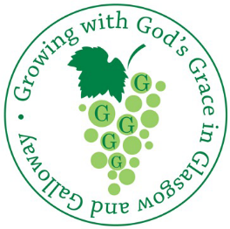
Regional Launch Service

The Launch of the Growth Strategy
Glasgow North East Region
Wednesday 22 June, 2011 at 7pm
St James the Less, Hilton Road, Bishopbriggs.
For more information, please contact Paul Hindle
SERVICES AND EVENTS
Sun 12th Whit Sunday (Pentecost)
9.15am Holy Communion (said)
10.30am Sung Eucharist
7.30pm Praise in the Park, Peel Park, Kirkintilloch
Thur 16th 10am Holy Communion in the Choir Vestry
Sat 18th 10am Strawberry Coffee Morning

Sun 19th Trinity Sunday
10.30am Sung Eucharist
3pm Afternoon Service in the hall
Wed 22nd 6.30/7pm MU night out at Boathouse
7.30pm Growth Strategy Launch Service,
St James, Bishopbriggs
Thur 23rd Corpus Christi
10am Holy Communion in the Choir Vestry
Fri 24th The Birth of John the Baptist

Sun 26th The First Sunday after Trinity
9.15am Holy Communion (said)
10.30am Sung Eucharist
Wed 29th Peter and Paul, Apostles
Thur 30th 10am Holy Communion in the Choir Vestry


Attention All Jam Makers
There is a quantity of empty jam jars and 1kg bags of cane sugar available at church for any jam-makers who are in need of supplies.
Please see Moira or Kathryn if you need any.
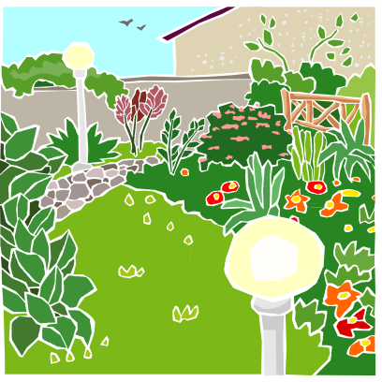
Lenzie
Open Gardens Weekend
18th & 19th June 2011
Come along a see some local colour
Look out for leaflets in church with details of gardens and opening times.
Free entry - donations for charity invited.


MU Night Out

at the Boathouse, Auchenstarry Marina, Kilsyth
Wednesday 22nd June 2011 @ 6.30 for 7pm

Praise in the Park
Timed to coincide with the Kirkintilloch Gala,
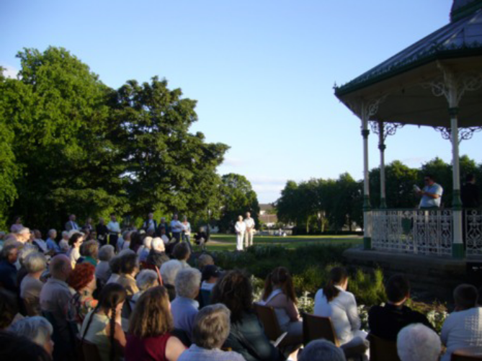
this open air service will take place on
Sunday 12th June 2011 from 7.30 to 8.15pm
at Peel Park.
If the weather is bad -
”Hallelujah in the Hall” at St Nininan’s.

Please Note!
There will be no Thursday morning Eucharist on the following dates throughout July.
7th July ; 14th July; 21st July; 28th July;
Thursday morning services will resume on the 4th August. Thanks Moira
St Cyprian’s Copyright licence CCL796007
Please send any notices to kathryn.potts2@ntlworld.com or call 578 0734 before 6.00pm each Wednesday. Thank you


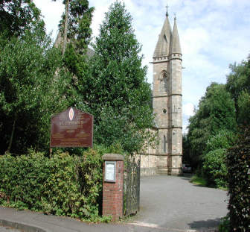
St Cyprian’s Scottish Episcopal Church,
Beech Road, Lenzie
Scottish Charity No. SCO03826

Strawberry Tea

St Cyprian’s Church Hall
Saturday 18th June 2011
10am – 12noon

Please come along and join in the fun
Everything Strawberries


Strawberry Teas
Cake & Candy, Bookstall,
Bottle Tombola,
Chocolate Fountain

Please see over for more !

Help is needed for this Strawberry Morning

- Volunteers to make scones
- Donations for the cake and candy stall
- Donations of bottles for the tombola
- Volunteers to help lay out the tables on Friday night after the dancing
- Volunteers to help serve in the coffee room and man the stalls
For more information please phone
Susan on 776 4135

