

“For we do not proclaim ourselves; we proclaim Jesus Christ as Lord”
1 Corinthians 2 v 4

WELCOME TO ST CYPRIAN’S EPISCOPAL CHURCH
THE LINK – Sunday 29th November, 2009
The First Sunday of Advent

We welcome all visitors to our service and
invite you to join us for coffee in the hall after the 10.30am service.

9.15am – Holy Communion

10.30am – Sung Eucharist

Notices

Introit hymn: 24 Hark, a thrilling voice is sounding....
Sharing of the peace

Service of The Eucharist using the 1982 ‘BLUE BOOK’

COLLECT: Almighty God, give us grace to cast away the works of darkness and to put on the armour of light, now in the time of this mortal life, in which your Son Jesus Christ came to us in great humility; that on the last day, when he shall come again in his glorious majesty to judge the living and the dead, we may rise to the life immortal; through him who is alive and reigns with you, in the unity of the Holy Spirit, one God, now and for ever.

FIRST READING: Jeremiah 33.14-16 (Sally Pitches)
The days are surely coming, says the Lord, when I will fulfil the promise I made to the house of Israel and the house of Judah. In those days and at that time I will cause a righteous Branch to spring up for David; and he shall execute justice and righteousness in the land. In those days Judah will be saved and Jerusalem will live in safety. And this is the name by which it will be called: ‘The Lord is our righteousness.’

RESPONSORIAL PSALM: Psalm 25
The response is:- To you, O Lord, I lift up my soul
O my God, in you I trust; do not let me be put to shame; do not let my enemies exult over me. Do not let those who wait for you be put to shame; let them be ashamed who are wantonly treacherous. - R
Make me to know your ways, O Lord; teach me your paths. Lead me in your truth, and teach me, for you are the God of my salvation; for you I wait all day long. - R
Be mindful of your mercy, O Lord, and of your steadfast love, for they have been from of old. Do not remember the sins of my youth or my transgressions; according to your steadfast love remember me, for your goodness’ sake, O Lord! - R
Good and upright is the Lord; therefore he instructs sinners in the way. He leads the humble in what is right, and teaches the humble his way. - R

EPISTLE: 1Thessalonians 3.9-end (Anne Carswell)
How can we thank God enough for you in return for all the joy that we feel before our God because of you? Night and day we pray most earnestly that we may see you face to face and restore whatever is lacking in your faith.
Now may our God and Father himself and our Lord Jesus direct our way to you. And may the Lord make you increase and abound in love for one another and for all, just as we abound in love for you. And may he so strengthen your hearts in holiness that you may be blameless before our God and Father at the coming of our Lord Jesus with all his saints.

GRADUAL HYMN: Come now, O Prince of peace..... see below

1) Come now, O Prince of peace,
2) Come now, O God of love,
make us one body;
come, O Lord Jesus,
reconcile your people.
make us one body;
come, O Lord Jesus,
reconcile your people.

4) Come, Hope of unity,
make us one body;
come, O Lord Jesus,
reconcile all nations.
3) Come now and set us free,
O God, our Saviour;
come, O Lord Jesus,
reconcile all nations.

Geonyong Lee revised Marion Pope Music Geonyong Lee

GOSPEL: Luke 21.25-36
‘There will be signs in the sun, the moon, and the stars, and on the earth distress among nations confused by the roaring of the sea and the waves. People will faint from fear and foreboding of what is coming upon the world, for the powers of the heavens will be shaken. Then they will see “the Son of Man coming in a cloud” with power and great glory. Now when these things begin to take place, stand up and raise your heads, because your redemption is drawing near.’
Then he told them a parable: ‘Look at the fig tree and all the trees; as soon as they sprout leaves you can see for yourselves and know that summer is already near. So also, when you see these things taking place, you know that the kingdom of God is near. Truly I tell you, this generation will not pass away until all things have taken place. Heaven and earth will pass away, but my words will not pass away.
‘Be on guard so that your hearts are not weighed down with dissipation and drunkenness and the worries of this life, and that day does not catch you unexpectedly, like a trap. For it will come upon all who live on the face of the whole earth. Be alert at all times, praying that you may have the strength to escape all these things that will take place, and to stand before the Son of Man.’

OFFERTORY: 336 All my hope on God is founded..... omit V 2

COMMUNION HYMN: 265 O thou, who at thy Euch.... omit V 3
POST COMMUNION:
O Lord our God, make us watchful and keep us faithful as we await the coming of your Son our Lord; that, when he shall appear, he may not find us sleeping in sin but active in his service and joyful in his praise; through Jesus Christ our Lord.
RECESSIONAL HYMN: 28 Lo, he comes with clouds descending....
Kirkintilloch and Lenzie ACTS
Advent Study Groups
Tuesday December 1st
at 7.30pm in St. Cyprian’s
Wednesday December 9th
at 7.30pm in Harestanes Community Centre,
BLESSING DISMISSAL

THIS WEEK IN PRAYER
Pray for the peace of Jerusalem: “May they prosper who love you,” Psalm 122:6
For your prayers this week:
In the Anglican Cycle of Prayer, we are asked to pray for West Texas - (Province VII, USA) The Rt Revd Gary Lillibridge; Suffragan Bishop of West Texas - (Province VII, USA) The Rt Revd David Mitchell Reed. In our own Diocese, please pray for Christ Church, Lanark (Dan Gafvert).
DAILY PRAYERS
30th For the people of Scotland and the Scottish Government
DECEMBER
1st For all AIDS victims and those infected with HIV
2nd For all those working in the postal and courier services
3rd For Samaritan’s Purse and Operation Christmas Child
4th The Anglican Consultative Council and John Stuart
5th For the People of Finland (National Independence Day)
Please also remember in your prayers:
Susan Frost; Ray Hardman; Mary Kitching; Brian and Kate MacDonald; Bill Morris; Vera Petzold; Bob Provan; Hannah Rose; Geoff and all those on the prayer board.
May God keep them all in His care.

SERVICES AND EVENTS NOVEMBER
Sun 29th First Sunday of Advent
9.15am Holy Communion (said)
10.30am Sung Eucharist
6.30pm Ecumenical Advent Service
at St David’s Memorial Park Church
Mon 30th Andrew, Apostle, Patron of Scotland
DECEMBER 2009
Tues 1st 7.30pm ACTS Advent Study at St Cyprian’s
Thur 3rd 10am Holy Communion in Choir Vestry
Sat 5th 10am-4pm Children’s Craft Day
Sun 6th Second Sunday of Advent
9.15am Holy Communion (said)
10.30am Sung Eucharist
3pm Holy Communion at Lillyburn
Tue 8th Conception of Mary, Mother of the Lord
Wed 9th 7.30pm Mother’s Union Christmas Night
7.30pm Acts Adv/Std, Harestanes Baptist
Thur 10th 10am Holy Communion in choir vestry
Sun 13th Third Sunday of Advent
9.15am Holy Communion (said)
10.30am Sung Eucharist


Crafts and Christmas Shopping


Would you like to do some Christmas Shopping while your children have fun doing crafts?

Bring your children along to the Church Hall
St. Cyprian’s Episcopal Church
Beech Road

LENZIE

On Saturday 5th December
Session One From 10.00am to 1.00pm Session Two 1.00pm to 4.00pm
(please bring snack lunch if required)

Christmas Card Making and lots of other craft fun!
£5:00 per child per session
All staff Scroll Checked by Disclosure Scotland
To book a place please email: moira.jamieson@ntlworld.com
(With details of children and age group.)

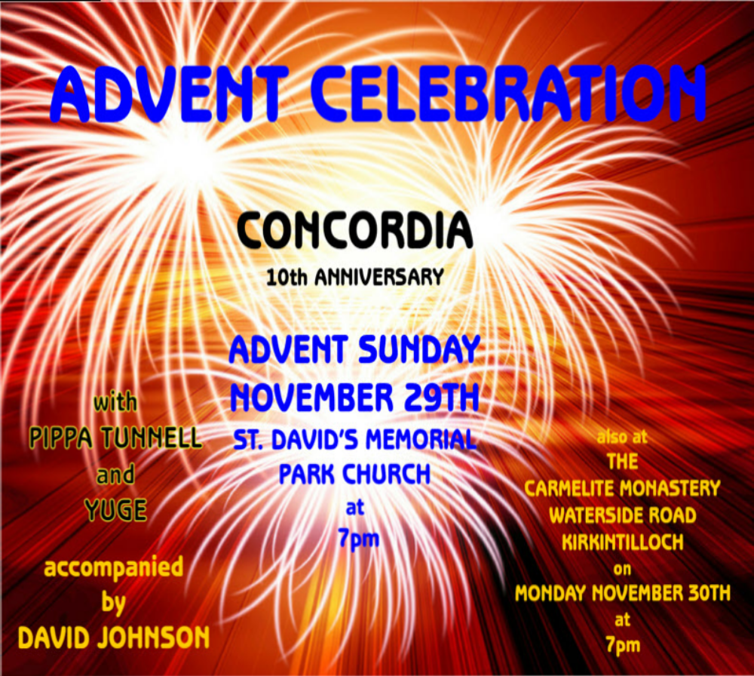

Please forward notices to Kathryn Potts on kathryn.potts2@ntlworld.com
or telephone on 578 0734, by 6.00pm each Wednesday. Thank you.

