
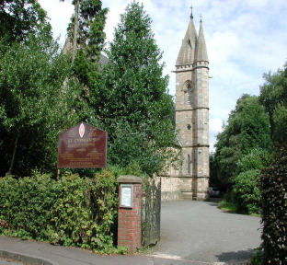
St Cyprian’s Scottish Episcopal Church,
Scottish Charity No. SCO03826
Beech Road, Lenzie
Strawberry
Coffee Morning

St Cyprian’s Church Hall
Saturday 18th June 2011
10am – 12noon

Please come along and join in the fun

Everything Strawberries


Strawberry Teas
Cake & Candy,
Bottle Tombola,

